**Student name: Ng Yat Lung**

**Student No.: 57170429**

**Input requirements**

Customer name

* English words only

Transaction type

* “ C “ or “ D “ only

Transaction amount

* Number only

**Flow chart**

Show adjusted data

Valid Data input

Invalid Data input

User enter corresponding data

Show corresponding menu

Menu 3

Valid input except 3

Invalid input

Input is Q

Show data in datafile

Wait for user enter

Quit simple billing system

**Test report**

**Case 1 with datafile0.dat**

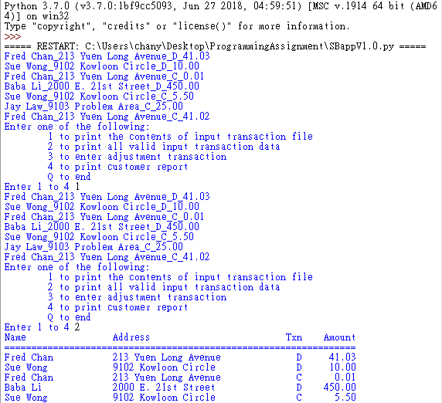

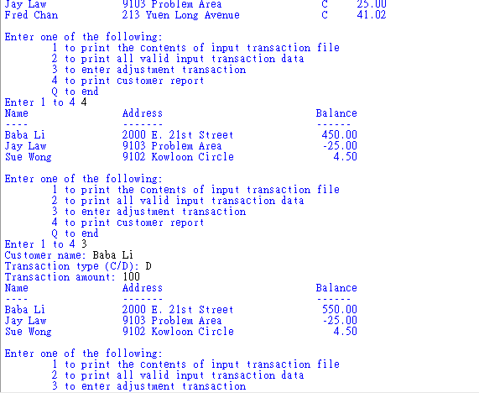



**Test case 2 with datafile1.dat (Invalid data included)**

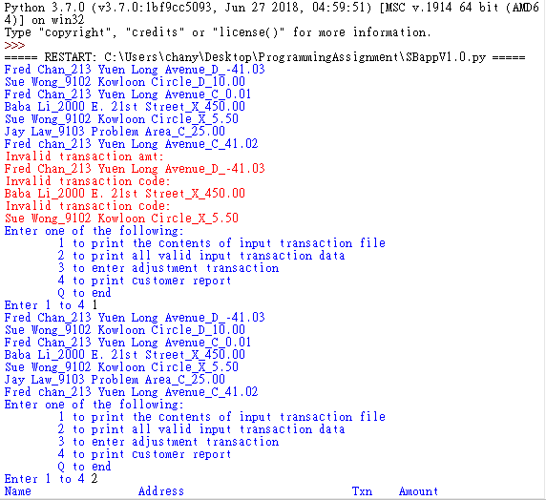

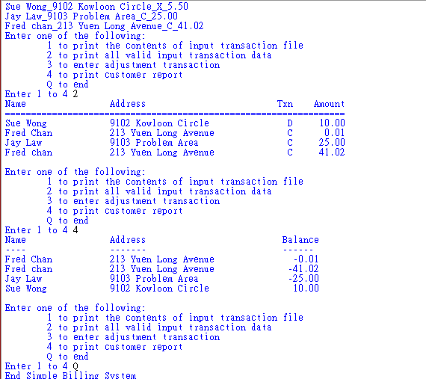

**Test case 3 with datafile2.dat (empty file)**

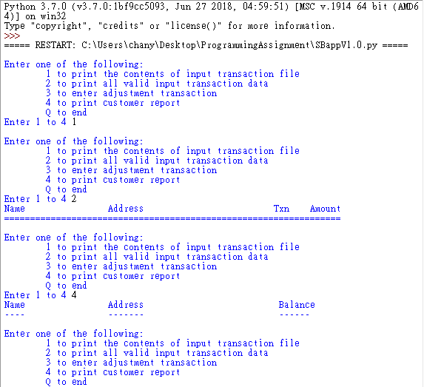



**Test case 4 with datafile0.dat (Invalid user input)**

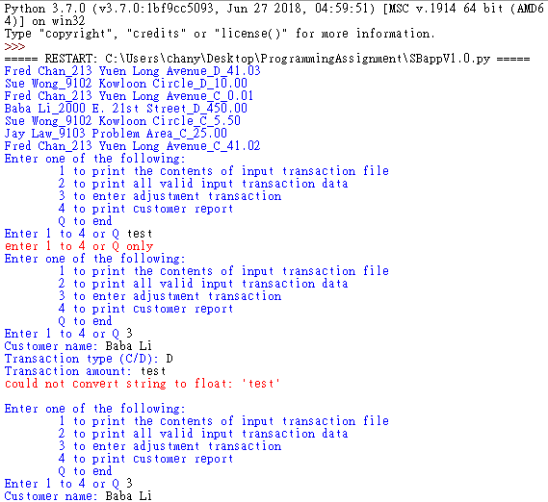

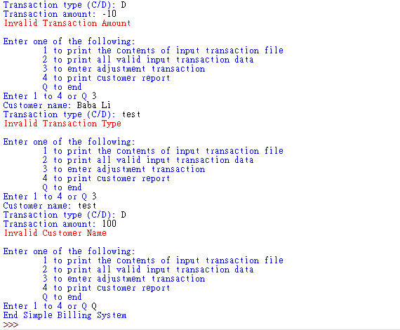

**User and technical documentation**

* Tested and successfully run on Python 3.7.0(64 bit), 3.8.10 and 3.10.1
* Open by right click SBapp.py > edit with IDLE > Run > Run Module
* Input data as the prompt suggested
* Input Q to exit from any input prompt
* The file used in the application can be changed by modify the file name in SBappV1.0.py as below (datafile0.dat is used at default)



**Error messages**

>>>>>>>>>>>>>>>>>>>> incorrect character entered

>>>>>>>>>>>>>>>>>>>>> no matched customer name in datafile

>>>>>>>>>>>>>>>>>>> “C” or “D” only

>>>>>> enter number only

>>>>>>>>>>>>>>>>> enter positive number only

The above error is caused by wrong data input/ format

**Limitations**

* Invalid customer name can’t be detected at once
* Data file used in the application is difficult to change